Practical 1

**AIM: WRITE A SOLIDITY PROGRAM FOR VARIABLES AND DECISION MAKING.**

**Source Code:**

**Compile Contract:**

**Deploy Contract:**

Practical 2

**AIM: WRITE A SOLIDITY PROGRAM TO DEMONSTRATE LOOP STATEMENT.**

**Source Code:**

**// SPDX-License-Identifier: GPL-3.0**

**pragma solidity <0.9.0;**

**contract Loop {**

**function loop() pure public returns(uint result) {**

**for (uint i = 0; i < 10; i++){**

**if (i == 3){**

**continue;**

**}**

**if ( i == 5) {**

**break;**

**}**

**}**

**uint j;**

**while( j < 10 ) {**

**j++;**

**}**

**return j;**

**}**

**}**

**Compile Contract:**

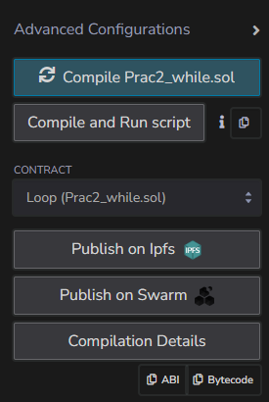

**Deploy Contract:**

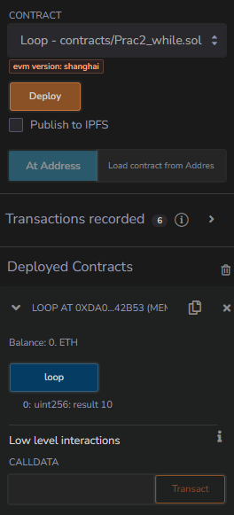

**Source Code:**

**// SPDX-License-Identifier: GPL-3.0**

**pragma solidity <0.9.0;**

**contract IfElse {**

**function foo(uint _x) public pure returns (uint) {**

**if (_x < 10 ){**

**return 0;**

**} else if ( _x < 20 ) {**

**return 1;**

**} else {**

**return 2;**

**}**

**}**

**function ternary(uint _x ) public pure returns (uint) {**

**return _x > 10 ? 1 : 2;**

**}**

**}**

**Compile Contract:**

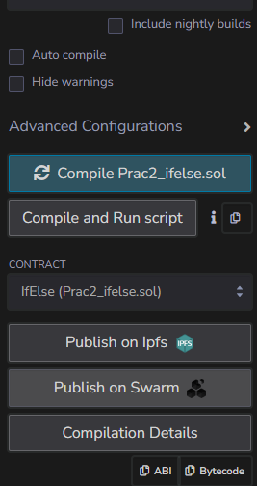

**Deploy Contract:**

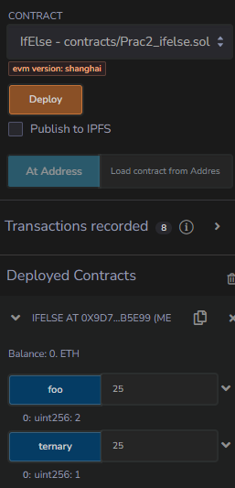

**Source Code:**

**// SPDX-License-Identifier: GPL-3.0**

**pragma solidity <0.9.0;**

**contract ForContract {**

**uint storedData;**

**function set(uint x) public {**

**storedData = x;**

**for (uint i = 0; i != 5; i++) {**

**storedData = storedData + i;**

**}**

**}**

**function get() public view returns (uint) {**

**return storedData;**

**}**

**}**

**Compile Contract:**

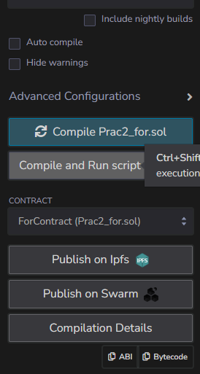

**Deploy Contract:**

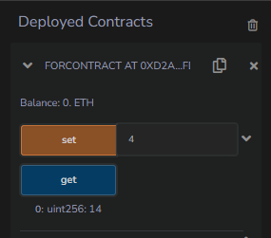

**Source Code:**

**// SPDX-License-Identifier: GPL-3.0**

**pragma solidity <0.9.0;**

**contract Types {**

**uint i = 10;**

**bool even;**

**function decision_making() public payable returns(bool) {**

**if (i % 2 == 0) {**

**even = true;**

**} else {**

**even = false;**

**}**

**return even;**

**}**

**}**

**Compile Contract:**

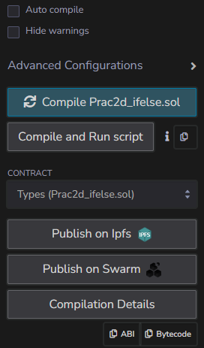

**Deploy Contract:**

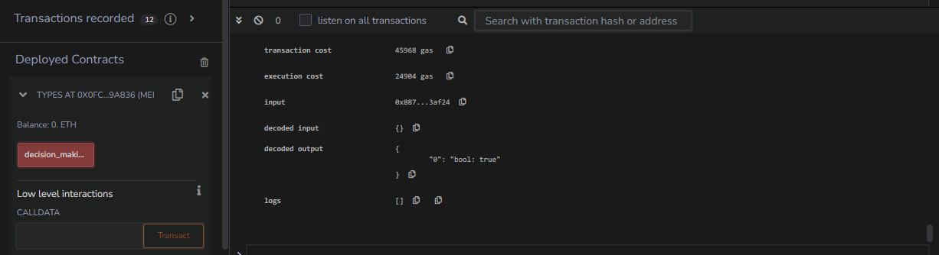

**Source Code:**

**// SPDX-License-Identifier: GPL-3.0**

**pragma solidity <0.9.0;**

**contract ifelseif {**

**uint i = 12;**

**string result;**

**function decision_making() public returns(string memory) {**

**if(i < 10){**

**result = "less than 10";**

**}**

**else if (i == 10){**

**result = "Equal to 10";**

**}**

**else {**

**result = "Greater than 10";**

**}**

**return result;**

**}**

**}**

**Compile Contract:**

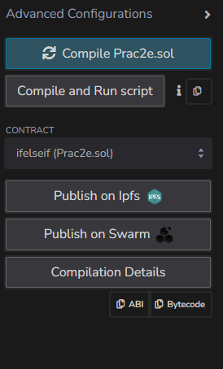

**Deploy Contract:**

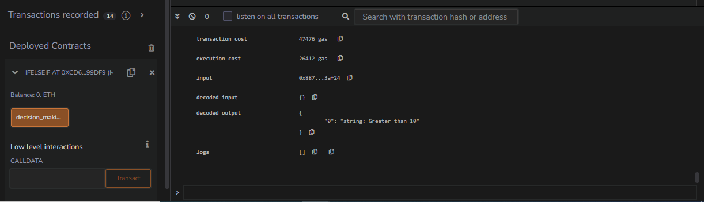

**Prac 3: Write a solidity program to demonstrate arrays and constructor**

**Array**

**Source Code:**

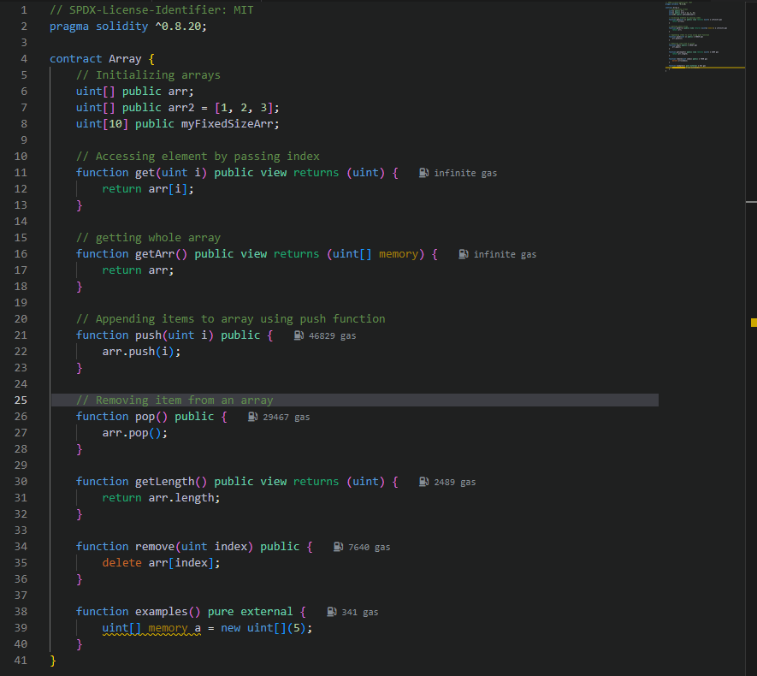

**Compile contract:**

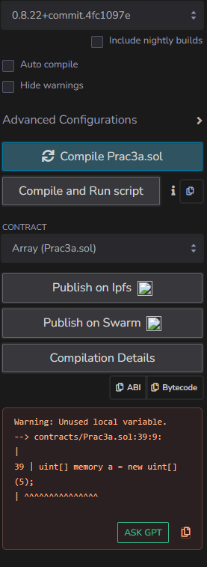

**Deploy contract:**

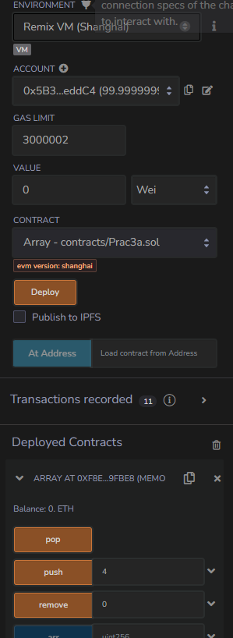

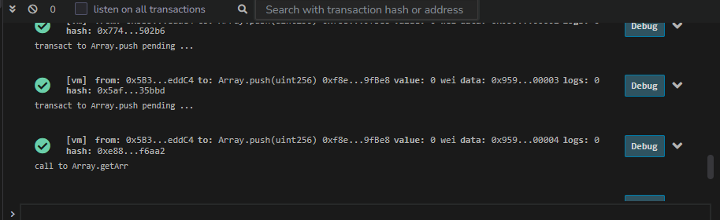

**Constructor Implmentation:**

**Source Code:**

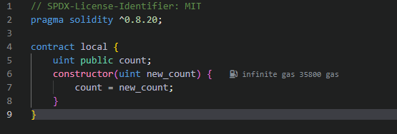

**Compile Contract:**

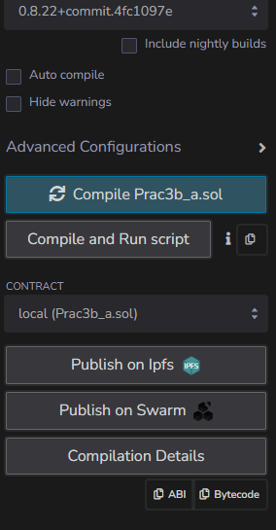

**Deploy Contract:**

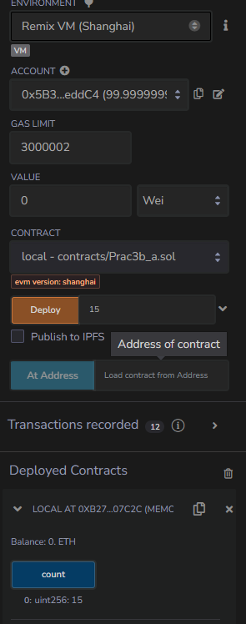

**Inheritance**

**Source Code:**

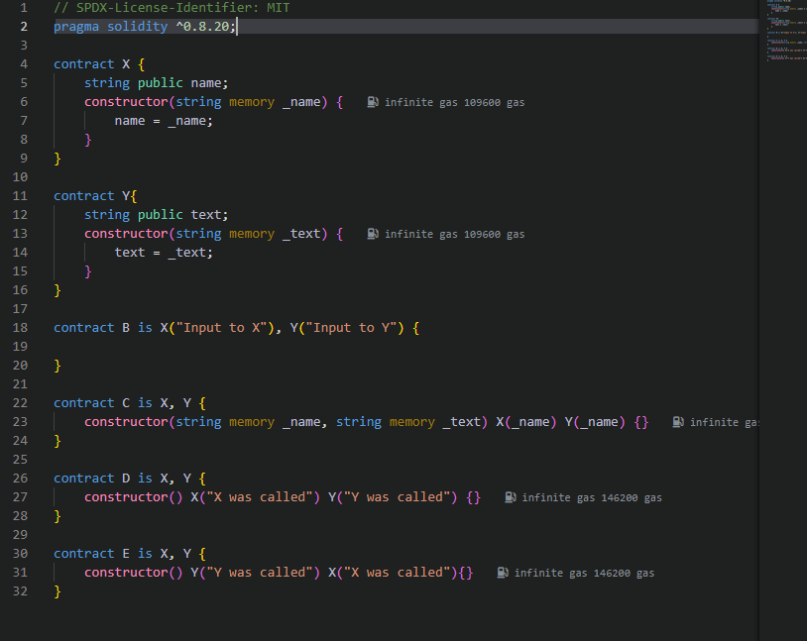

**Compile Contract:**

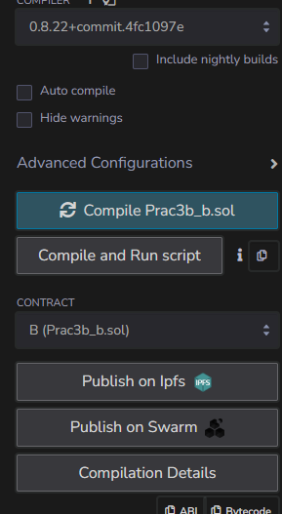

**Deploy Contract:**

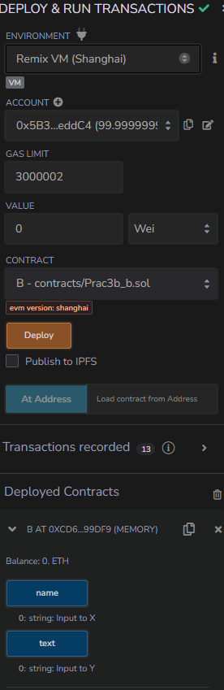

**Prac 4: Write a solidity program to demonstrate strings**

**Source Code:**

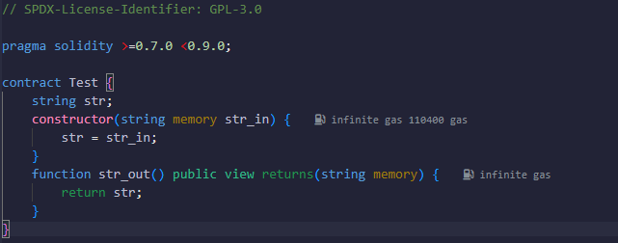

**Compile Contract:**

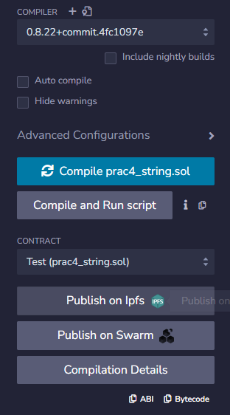

**Deploy Contract:**

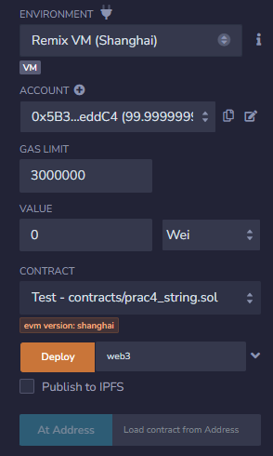

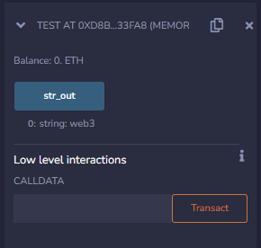

**Concatenate String:**

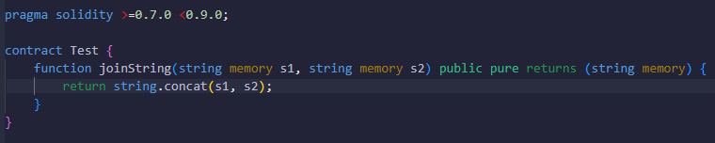

**Deploy Contract:**

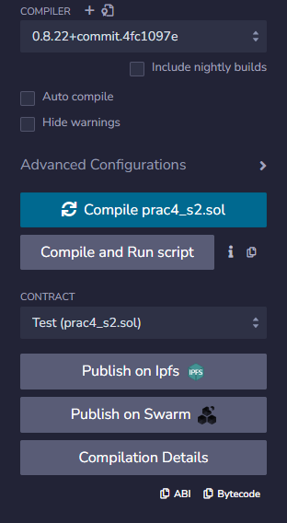

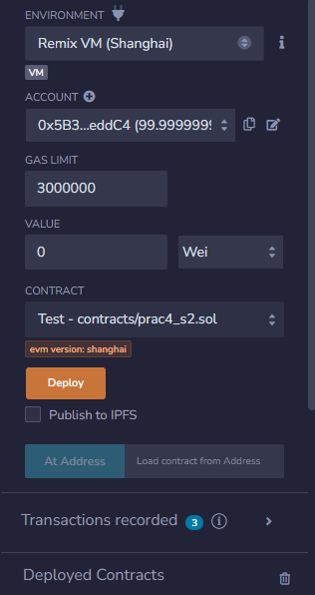

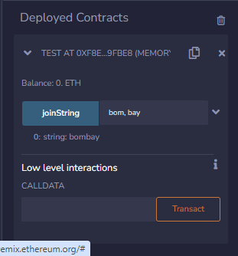

**Code:**

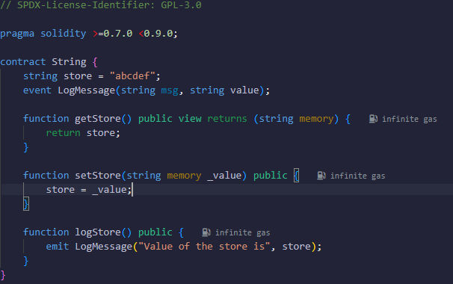

**Compile Contract:**

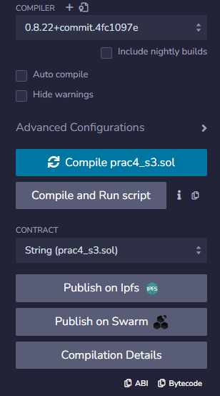

**Deploy Code:**

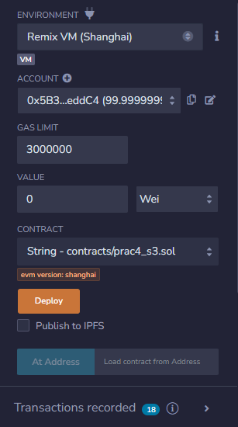

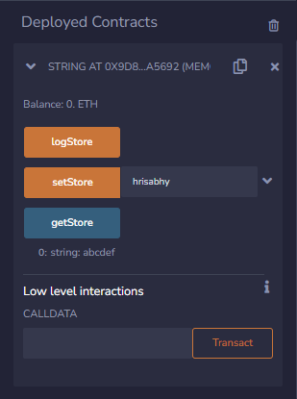

**Prac 5: Write a solidity program to demonstrate structure and enumerator**

**Code:**

**// SPDX-License-Identifier: GPL-3.0**

**pragma solidity <0.9.0;**

**contract Types{**

**enum week_days{**

**Monday,**

**Tuesday,**

**Wednesday,**

**Thrusday,**

**Friday,**

**Saturday,**

**Sunday**

**}**

**week_days week;**

**week_days choice;**

**week_days constant default_value = week_days.Sunday;**

**function set_value() public {**

**choice = week_days.Thrusday;**

**}**

**function get_choice() public view returns(week_days){**

**return choice;**

**}**

**function getdefaultvalu() public pure returns(week_days) {**

**return default_value;**

**}**

**}**

**Compile contract:**

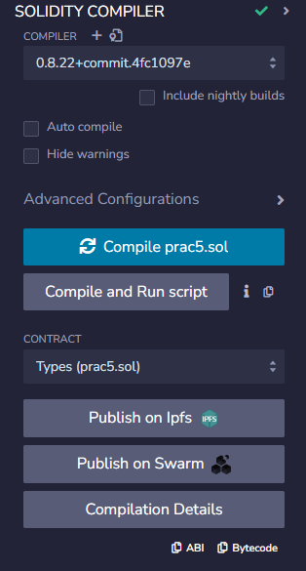

**Deployed contract:**

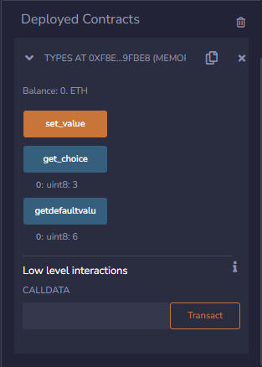

**2nd Program**

**// SPDX-License-Identifier: GPL-3.0**

**pragma solidity <0.9.0;**

**contract test{**

**struct Book{**

**string name;**

**string writer;**

**uint id;**

**bool available;**

**}**

**Book book1;**

**Book book2 = Book("Building Etherium DApps", "Roberto Infante", 2, false);**

**function set_book_detail() public{**

**book1 = Book("Introducing Etherium & Solidity", "Chris Damen", 1, true);**

**}**

**function book_info() public view returns(string memory, string memory, uint, bool){**

**return(book2.name, book2.writer, book2.id, book2.available);**

**}**

**function get_details() public view returns(string memory, uint) {**

**return (book1.name, book1.id);**

**}**

**}**

**Compile Code:**

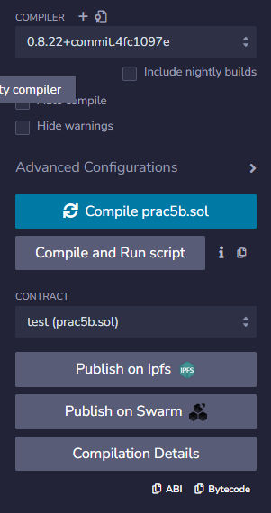

**Deploy Code:**

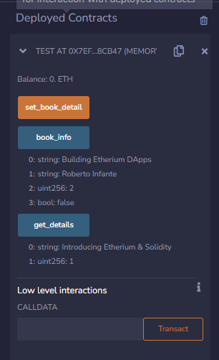

**Prac 6: Write the following programs for blockchain in python**

1. **A simple client class that generates the private and public key by using the built in python RSA algorithm and test it**
2. **A transaction class to send and receive money and test it.**

**Code:**

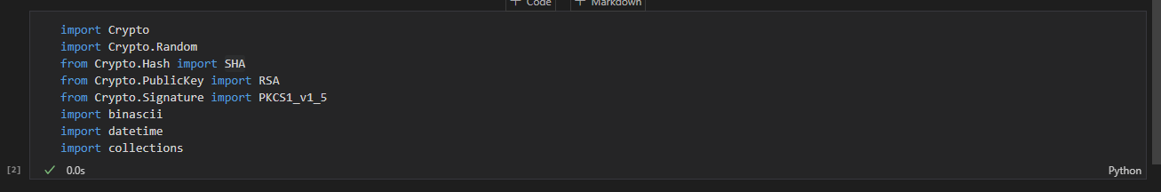

**class Client:**

**def __init__(self) -> None:**

**random = Crypto.Random.new().read**

**self._private_key = RSA.generate(1024, random)**

**self._public_key = self._private_key.public_key()**

**self._signer = PKCS1_v1_5.new(self._private_key)**

**@property**

**def identity(self):**

**return binascii.hexlify(self._public_key.export_key(format="DER")).decode('ascii')**

**class Transaction:**

**def __init__(self, sender, recipent, value) -> None:**

**self.sender = sender**

**self.recipent = recipent**

**self.value = value**

**self.time = datetime.datetime.now()**

**def to_dict(self):**

**if self.sender == "Genesis":**

**identity = "Genesis"**

**else:**

**identity = self.sender.identity**

**return collections.OrderedDict({**

**'sender': identity,**

**"recipent": self.recipent,**

**"value": self.value,**

**"time": self.time**

**})**

**def sign_transaction(self):**

**private_key = self.sender._private_key**

**signer = PKCS1_v1_5.new(private_key)**

**h = SHA.new(str(self.to_dict()).encode('utf8'))**

**return binascii.hexlify(signer.sign(h)).decode('ascii')**

**Prac 7**

**Code:**

**import Crypto**

**import Crypto.Random**

**from Crypto.Hash import SHA**

**from Crypto.PublicKey import RSA**

**from Crypto.Signature import PKCS1_v1_5**

**import binascii**

**import datetime**

**import collections**

**def display_transaction(transaction):**

**dict = transaction.to_dict()**

**print("sender" + dict['sender'])**

**print("-----")**

**print("recipent" + dict['recipent'])**

**print("-----")**

**print("value:" + str(dict['value']))**

**print("-----")**

**print("time:" + str(dict['time']))**

**print("-----")**

**class Client:**

**def __init__(self) -> None:**

**random = Crypto.Random.new().read**

**self._private_key = RSA.generate(1024, random)**

**self._public_key = self._private_key.public_key()**

**self._signer = PKCS1_v1_5.new(self._private_key)**

**@property**

**def identity(self):**

**return binascii.hexlify(self._public_key.export_key(format="DER")).decode('ascii')**

**class Transaction:**

**def __init__(self, sender, recipent, value) -> None:**

**self.sender = sender**

**self.recipent = recipent**

**self.value = value**

**self.time = datetime.datetime.now()**

**def to_dict(self):**

**if self.sender == "Genesis":**

**identity = "Genesis"**

**else:**

**identity = self.sender.identity**

**return collections.OrderedDict({**

**'sender': identity,**

**"recipent": self.recipent,**

**"value": self.value,**

**"time": self.time**

**})**

**def sign_transaction(self):**

**private_key = self.sender._private_key**

**signer = PKCS1_v1_5.new(private_key)**

**h = SHA.new(str(self.to_dict()).encode('utf8'))**

**return binascii.hexlify(signer.sign(h)).decode('ascii')**

**transactions = []**

**Dinesh = Client()**

**Ramesh = Client()**

**Seema = Client()**

**Vijay = Client()**

**t1 = Transaction(**

**Dinesh,**

**Ramesh.identity,**

**15.0**

**)**

**t1.sign_transaction()**

**transactions.append(t1)**

**t2 = Transaction(Dinesh, Seema.identity, 6.0)**

**t2.sign_transaction()**

**t3 = Transaction(Ramesh, Vijay.identity, 2.0)**

**t3.sign_transaction()**

**transactions.append(t3)**

**t4 = Transaction(**

**Seema,**

**Ramesh.identity,**

**4.0**

**)**

**t4.sign_transaction()**

**transactions.append(t4)**

**t5 = Transaction(**

**Vijay,**

**Seema.identity,**

**7.0**

**)**

**t5.sign_transaction()**

**transactions.append(t5)**

**t6 = Transaction(**

**Ramesh,**

**Seema.identity,**

**3.0**

**)**

**t6.sign_transaction()**

**transactions.append(t6)**

**t7 = Transaction(**

**Seema,**

**Dinesh.identity,**

**8.0**

**)**

**t8 = Transaction(**

**Seema,**

**Ramesh.identity,**

**1.0**

**)**

**t8.sign_transaction()**

**transactions.append(t8)**

**t9 = Transaction(**

**Vijay,**

**Dinesh.identity,**

**5.0**

**)**

**t9.sign_transaction()**

**transactions.append(t9)**

**t10 = Transaction(**

**Vijay,**

**Ramesh.identity,**

**3.0**

**)**

**t10.sign_transaction()**

**transactions.append(t10)**

**for transaction in transactions:**

**display_transaction (transaction)**

**print ('--------------')**

**Output:**

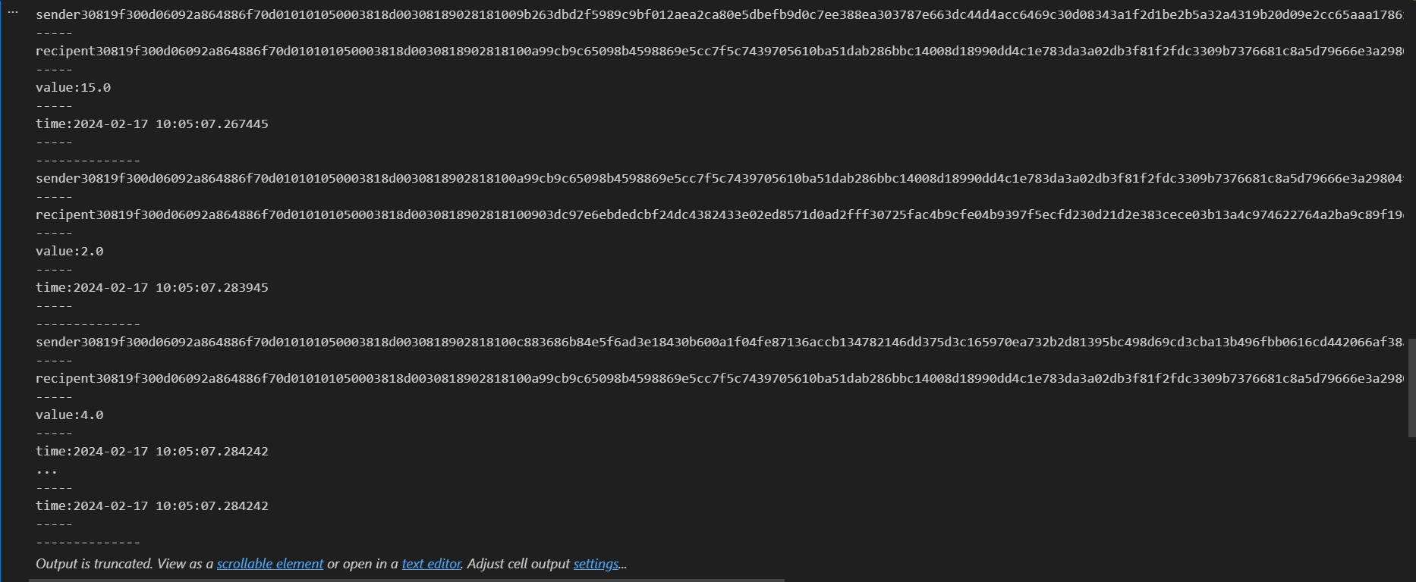

**class Block:**

**def __init__(self):**

**self.verified_transactions = []**

**self.previous_block_hash = ""**

**self.Nonce = ""**

**last_block_hash = ""**

**Dinesh = Client()**

**t0 = Transaction (**

**"Genesis",**

**Dinesh.identity,**

**500.0**

**)**

**block0 = Block()**

**block0.previous_block_hash = None**

**Nonce = None**

**block0.verified_transactions.append (t0)**

**digest = hash (block0)**

**last_block_hash = digest**

**TPCoins = []**

**def dump_blockchain (self):**

**print ("Number of blocks in the chain: " + str(len (self)))**

**for x in range (len(TPCoins)):**

**block_temp = TPCoins[x]**

**print ("block # " + str(x))**

**for transaction in block_temp.verified_transactions:**

**display_transaction (transaction)**

**print ('--------------')**

**print ('=====================================')**

**TPCoins.append (block0)**

**dump_blockchain(TPCoins)**

**Output:**

